OCARC Supply Inventory
06/25/2024

STORAGE = 18712 Sycamore Cir, Yorba Linda, CA [Mrs. Millard (N6TMT’s Mom)]
OLD LIST 08/23/2017:
Item # | Description | Comment | Location | Cost | Acquired
1 | Long grey box (“coffin”) – poles, stakes, light rope  3 each 40-ft push-up mast (military - in grey boxes with guy ropes) | See picture | STORAGE – for FD | Donated | 3/2005
2 | Long grey box (“coffin”) – poles, stakes, light rope | See picture | STORAGE – for FD | Donated
3 | Long grey box (“coffin”) – poles, stakes, light rope | See picture | STORAGE – for FD | Donated
4a  4b | 12 x 14 Coleman “walled tent” in canvas bag +  Canvas bag with poles/stakes | No picture | Not seen/touched | Donated | 2019
5 | “Rocket launcher” hub | See picture | STORAGE – for FD | Donated | 2015
6 | “Rocket launcher” hub | See picture | STORAGE – for FD | Donated | 2015
7 | 3 x foam interlocking pads | See picture | STORAGE – for FD
8 | “Rocket launcher” poles (multiple boxes):  - Military stacking mast "Rocket Launcher" (Chip design) 2 each  - Military stacking mast "Rocket Launcher" (modern design) 1 ea | See picture  See #35? | STORAGE – for FD | Donated | 2015
9 | Blue box on wheels: contents ??? | See picture | STORAGE – for FD | Donated
10 | White box: contents ??? | See picture | STORAGE – for FD | Donated
11 | Tent – Embark brand 4-person | See picture | STORAGE – for FD
12 | Twine – extremely long roll | See picture | STORAGE – for FD |  | 6/2019
13 | Clear tote/white cover – gloves, flags | See picture | STORAGE – for FD
14 | Clear green tote | See picture | STORAGE – for FD
15 | Clear tote | See picture | STORAGE – for FD
16 | Small swivel base | See picture | STORAGE – for FD
17 | Grey tote/black lid: Contents: Band Pass Filters:  - ICE Band-pass filters - 80M, 40M, 20M, 15M, 10M  - Home-made Band-pass filters - 40M, 20M, 15M, 10M | See picture | STORAGE – for FD | Donated | 03/2016
18 | Grey tote/black lid: Contents: ??? | See picture | STORAGE – for FD
19 | Tall cardboard box: Ropes | See picture | STORAGE – for FD
20 | 3 x heavy duty yellow extension cords (not sure of # or lengths) | See - FD Power Cables | STORAGE – for FD
21a  21b | 10 x 12 Coleman “walled tent” in green bag (a) +  green pole bag (b) | See pictures | STORAGE – for FD | Donated | 2015
22 | 2 x ½” (3/4”?) plywood about 4’x4’ | See picture | STORAGE – for FD
23 | Clear tote/blue lid: Contents ??? | See picture | STORAGE – for FD | Donated
24 | Clear tote/hinged black lid: Ropes | See picture | STORAGE – for FD | Donated
25 | Tent: 13 x 9 dome screen house | See picture | STORAGE – for FD
26 | Measuring wheel | See picture | STORAGE – for FD
27 | Metal stakes painted white | See picture | STORAGE – for FD
28 | 2 x 50’ aluminum towers (5 sections each) noted tower #1 & #2:  - 50 ft Aluminum Tower by Universal w/ Machined base  - 50 ft Aluminum Tower by Universal w/ bolted base | See picture | STORAGE – for FD | $900  $1300 | 6/2006  6/2008
29 | 2 x bases for towers #1 & #2 | See picture | STORAGE – for FD
30 | Antenna (various grouped as #30/#31. May be 3 antennas.):  - 3-element Force-12 20M light-weight beam  - 5-element Hygain 15M beam  - 3-element 10M beam | See picture | STORAGE – for FD | Donated
31 | Antenna (various grouped as #30/#31. May be 3 antennas.) | See item #30 | STORAGE – for FD | Donated
32 | Wire Antenna in small mailing box | No picture | STORAGE – for FD
33 | Sledgehammer | See picture | STORAGE – for FD
34 | Ground Rod | See picture | STORAGE – for FD
35 | Home Depot Rocket Launcher (X 2) | See picture | STORAGE – for FD
36 | Generator 5 KW – Honda – on wheels | No picture | Bob Eckweiler – AF6C | $1217 | 6/2000
 | FD Power Cables:  - 1ea - 100-ft 12 AWG cable with 2 receptacles,  - 1ea - 100-ft 10 AWG cable  - 1ea - 50-ft 10 AWG cable  - 5ea - 50-ft 12 AWG cables,  - 5ea - extension-cord outlet-boxes,  - 2-ea short "splitter" with 2 outlets, | See item #20 and some maybe in totes | STORAGE? | $375  $125 | 6/2011  6/2012
38 | 1ea - Generator power adapter cable: 4-wire to special 3-wire | See picture | Bob Eckweiler – AF6C
39 | 24-ft yellow plastic push-up | See picture | STORAGE | Donated | 3/2005
40 | 24-ft yellow plastic push-up | Same as #39 | Bob Eckweiler – AF6C | Donated | 3/2005
41 | Firman W03081 3300 WATT INVERTER Generator | See picture | ??? | $915 | 5/2021
42 | Power cable/adapter for Firman Generator | See picture | ??? with generator | $30parts | 5/2021
43 | Tool Box with tools (sockets, wrenches, pliers, tape measure, adapter kit, barrels, hose clamps, +++) | See picture | STORAGE | Donated | 6/2024
 | Coax (in boxes?):  - Coax - 100 ft RG-8X  - Coax - 50 ft RG-8X |  | STORAGE in boxes? |  | 8/2017  8/2017
 | Rayovac Lanterns - with battery, Field Day |  | STORAGE? – for FD |  | 6/2015
 | OCARC Banner |  | Bob Eckweiler – AF6C | Donated
 | OCARC Field Day banner |  | Bob Eckweiler – AF6C | $50 | 6/2013
 | C3 Antenna |  | Storage | Donated | 2023
 | Various Coax for FD |  | Storage | Donated | 2023
 | WFD Banner |  | Ron Mudry | Donated | 2020
 | ARRL Flag |  | ??? | $53 | 8/2002
 | American Flag (original lost) |  | RC storage cabinet | Donated | 1/2024
 | Kenwood TS-140S HF Rig w/ Astron RS-20 P/S (loaner for club members) |  | Steve KK6REB | Donated
 | Wooden Podium |  | Dan Dankert – N6PEQ | Donated
 | Laminating machine |  | Bob Eckweiler – AF6C | $54 | 1/2002
 | Corporate Seal |  | Bob Eckweiler – AF6C
 | Yaesu FT-757GX, PS, tuner |  | Gene Eckert KJ6OML | Donated | 10/2019

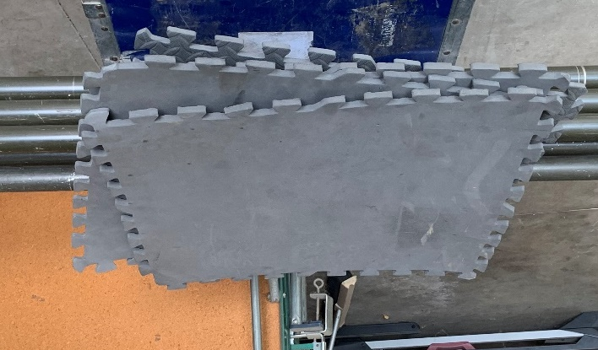
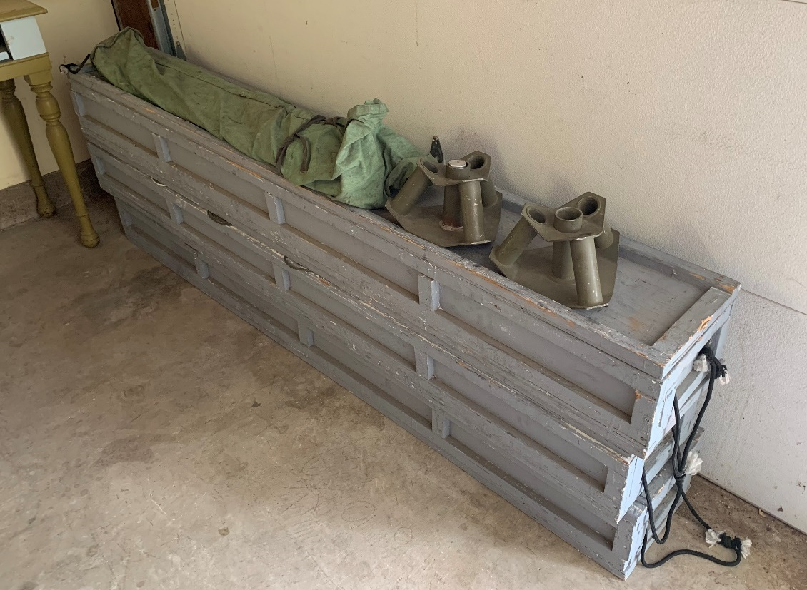
#21b #5 #6

#7

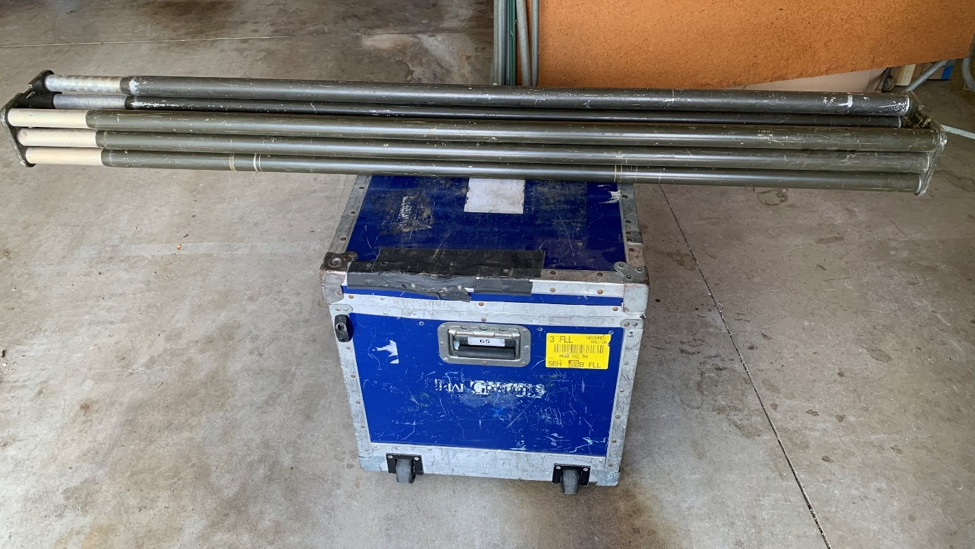
#8

#9
#1

#2

#3
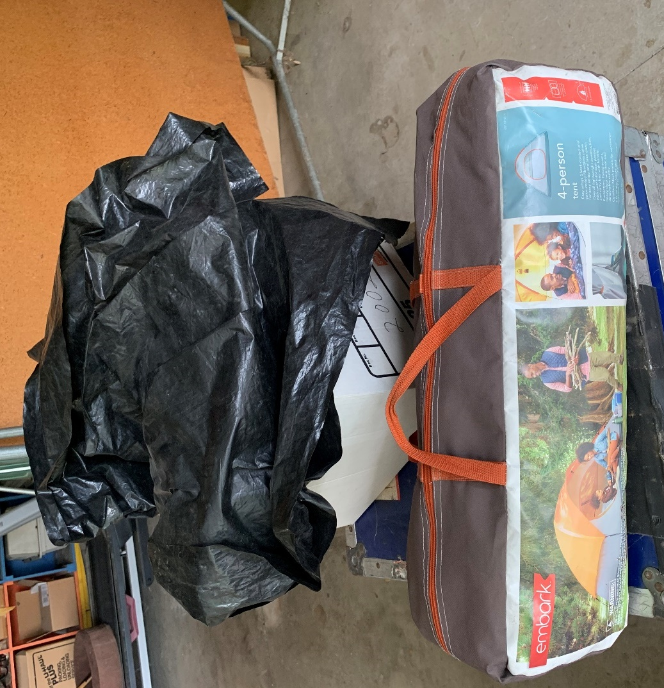
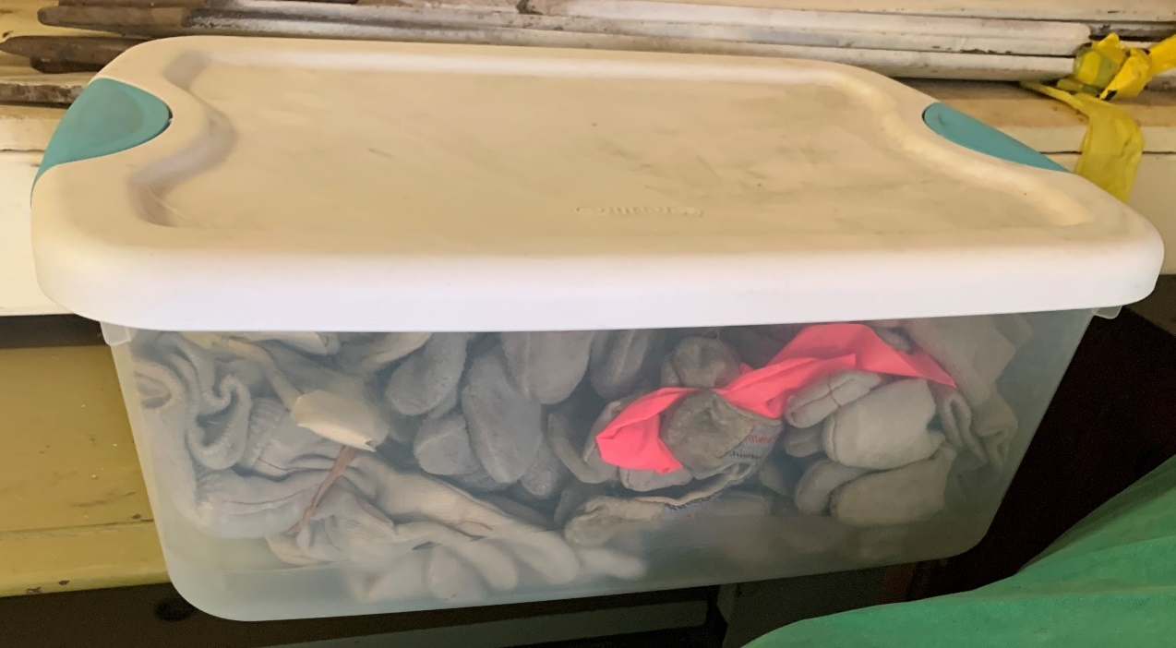
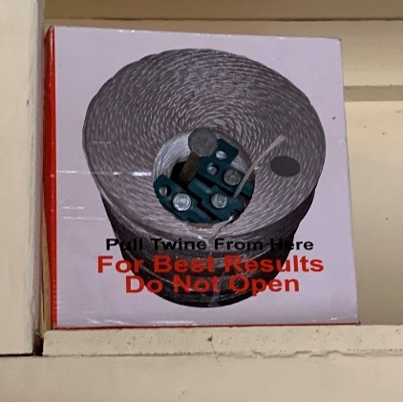
#13
#10

#11
#12
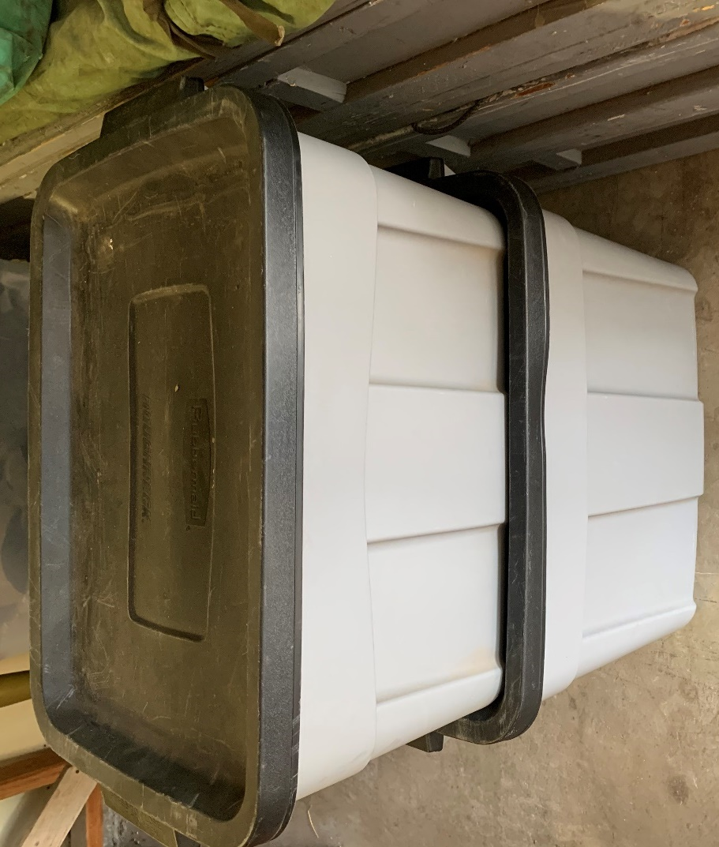
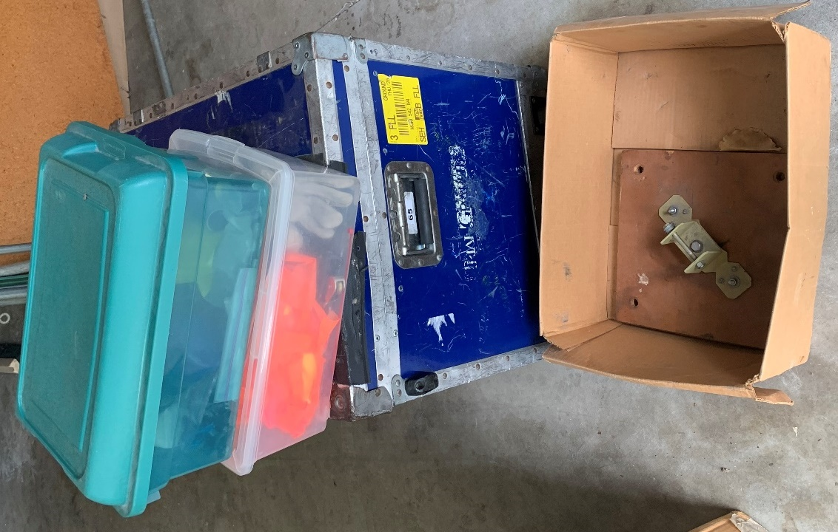
#17

#18
#14

#15

#16
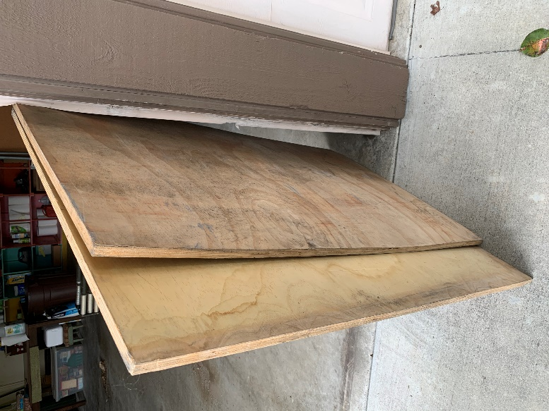
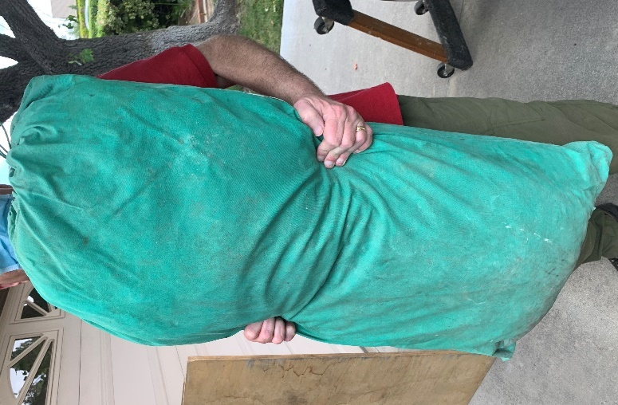
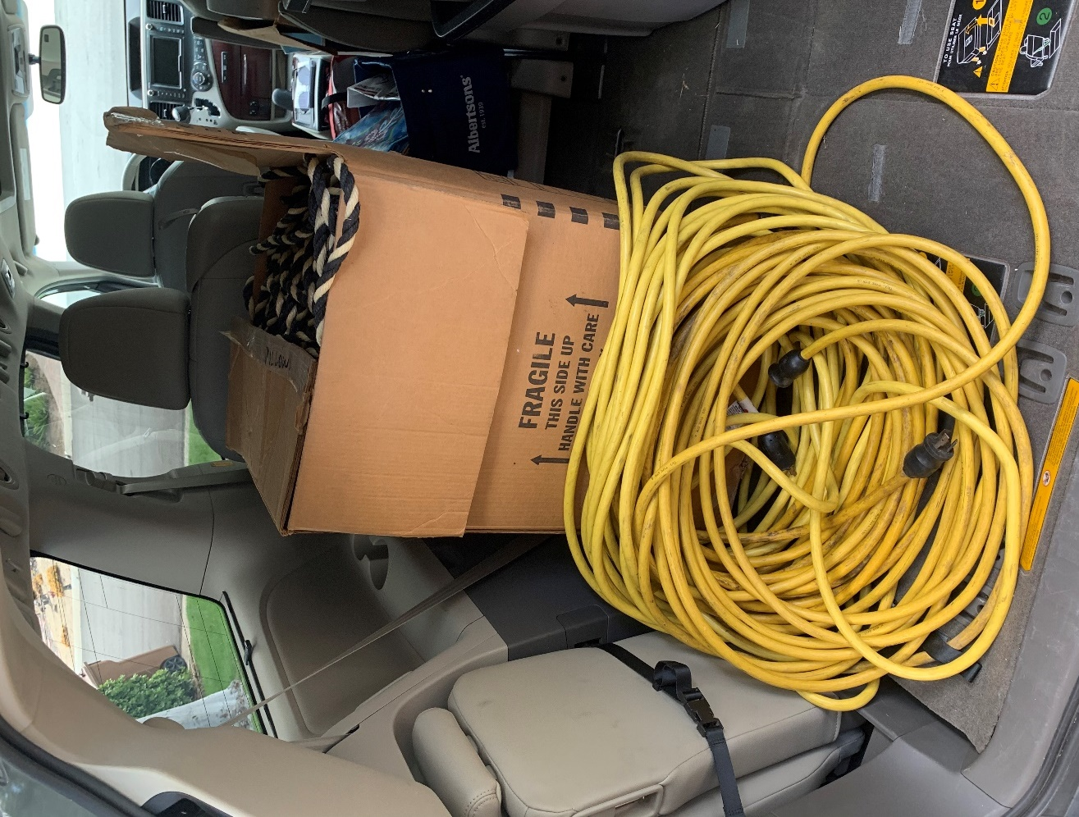
#22
#21a
#19

#20
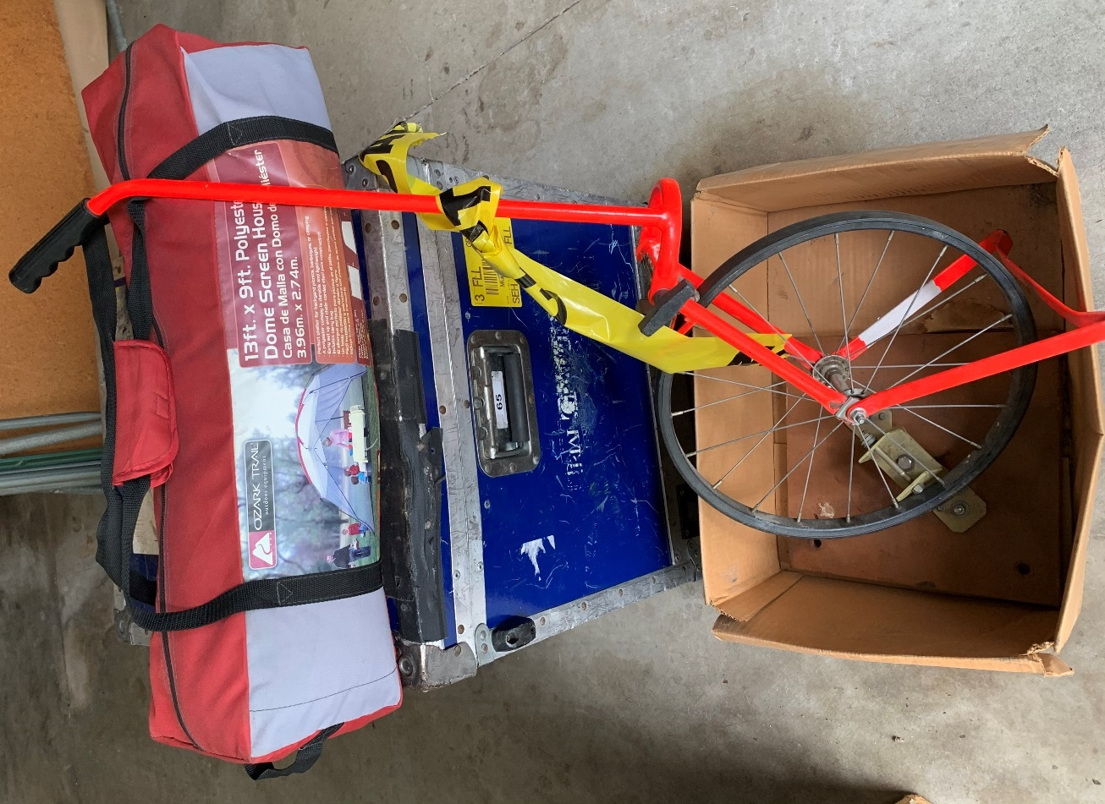
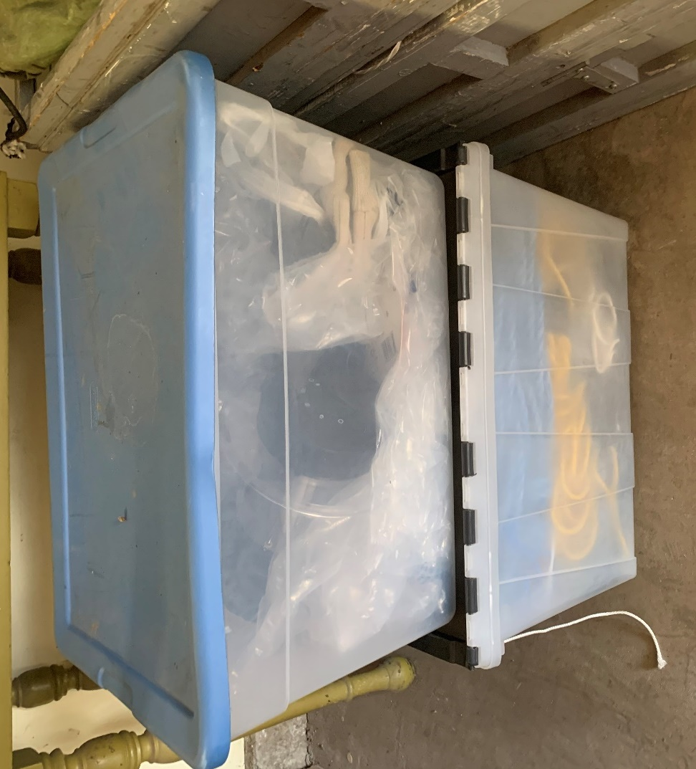
#25

#26
#23

#24

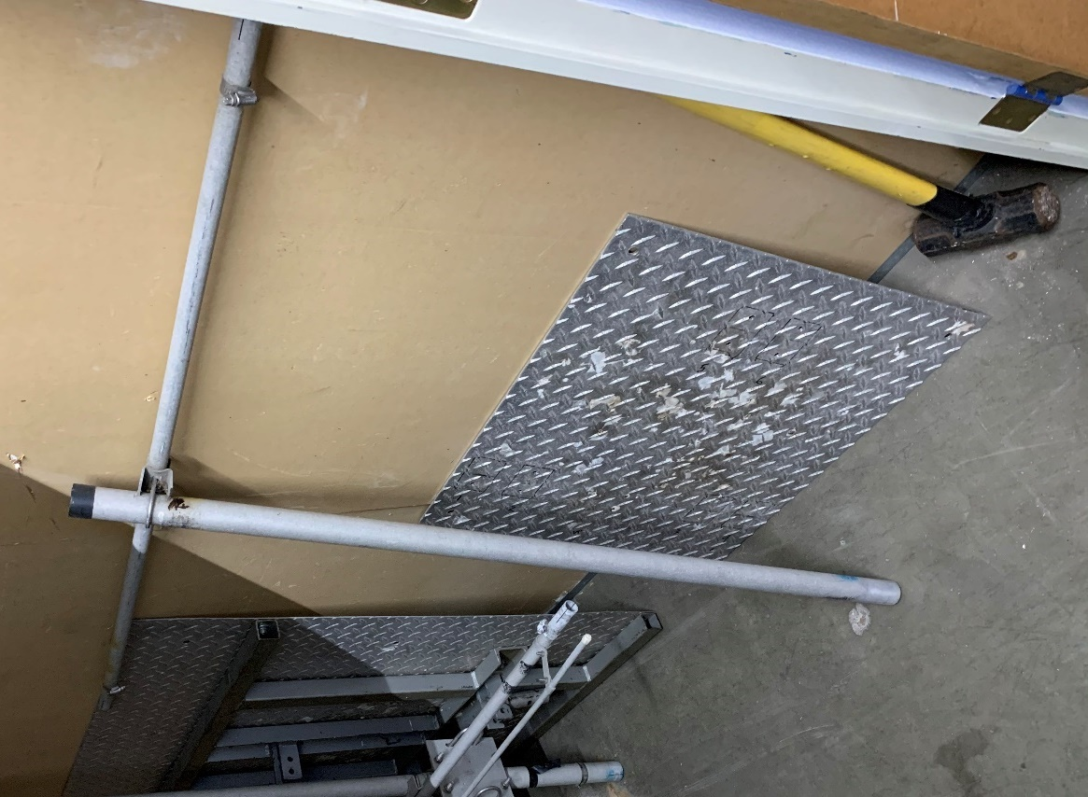
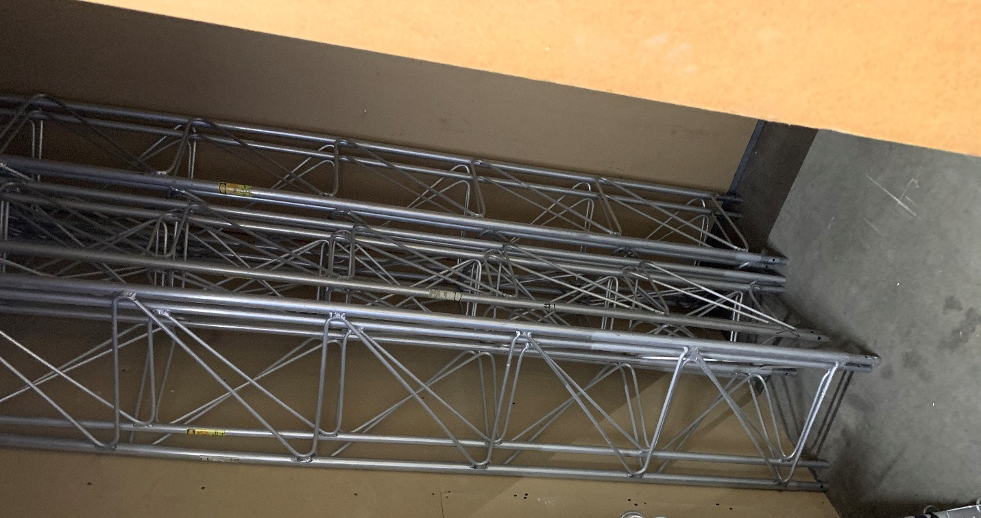
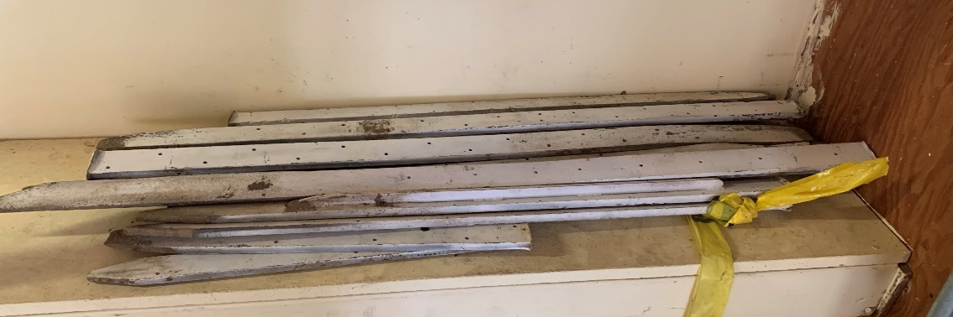
#33
#29a
#28
#27
Antenna Pieces #30 & #31 (Maybe 10M, 15M, 20M monobanders):
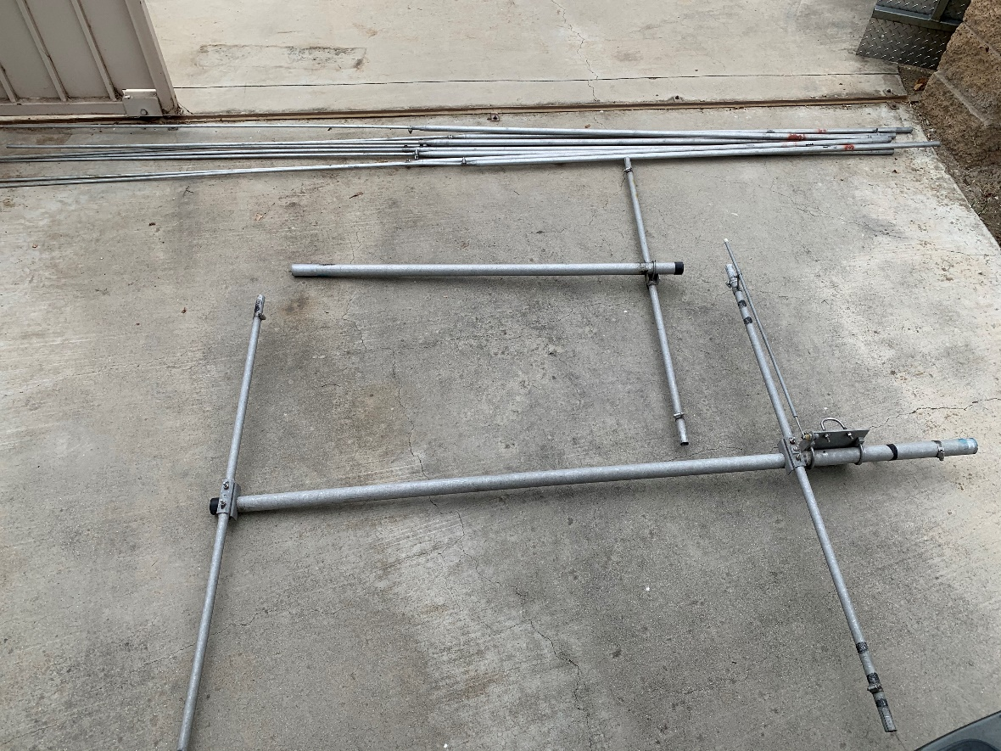
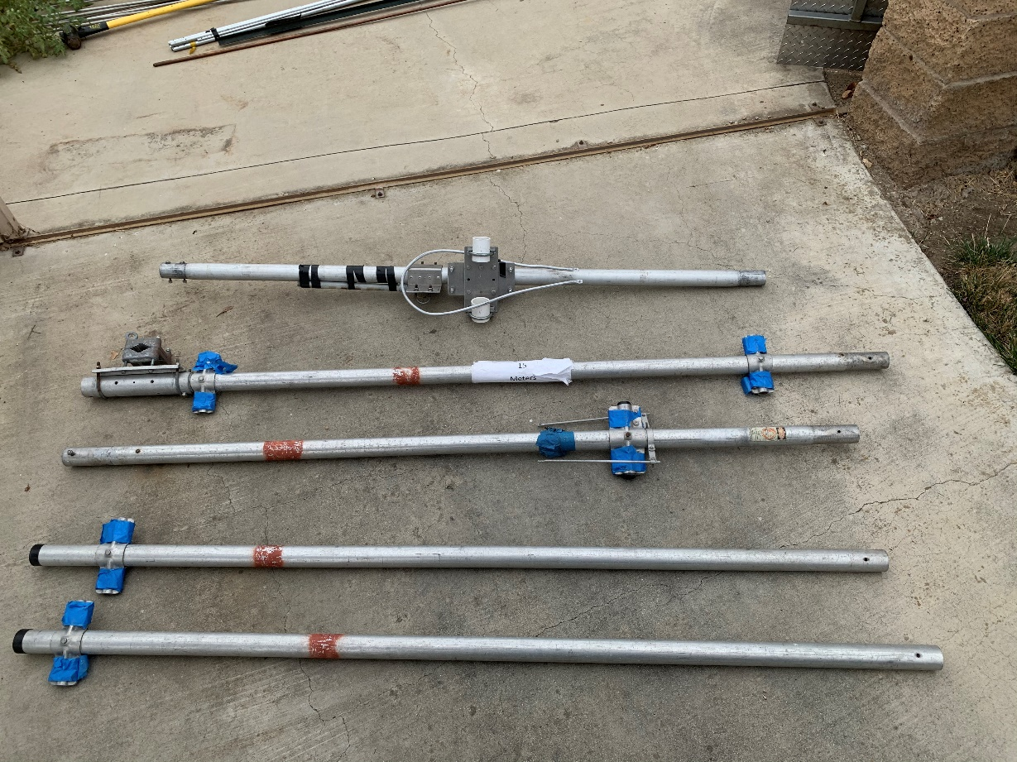
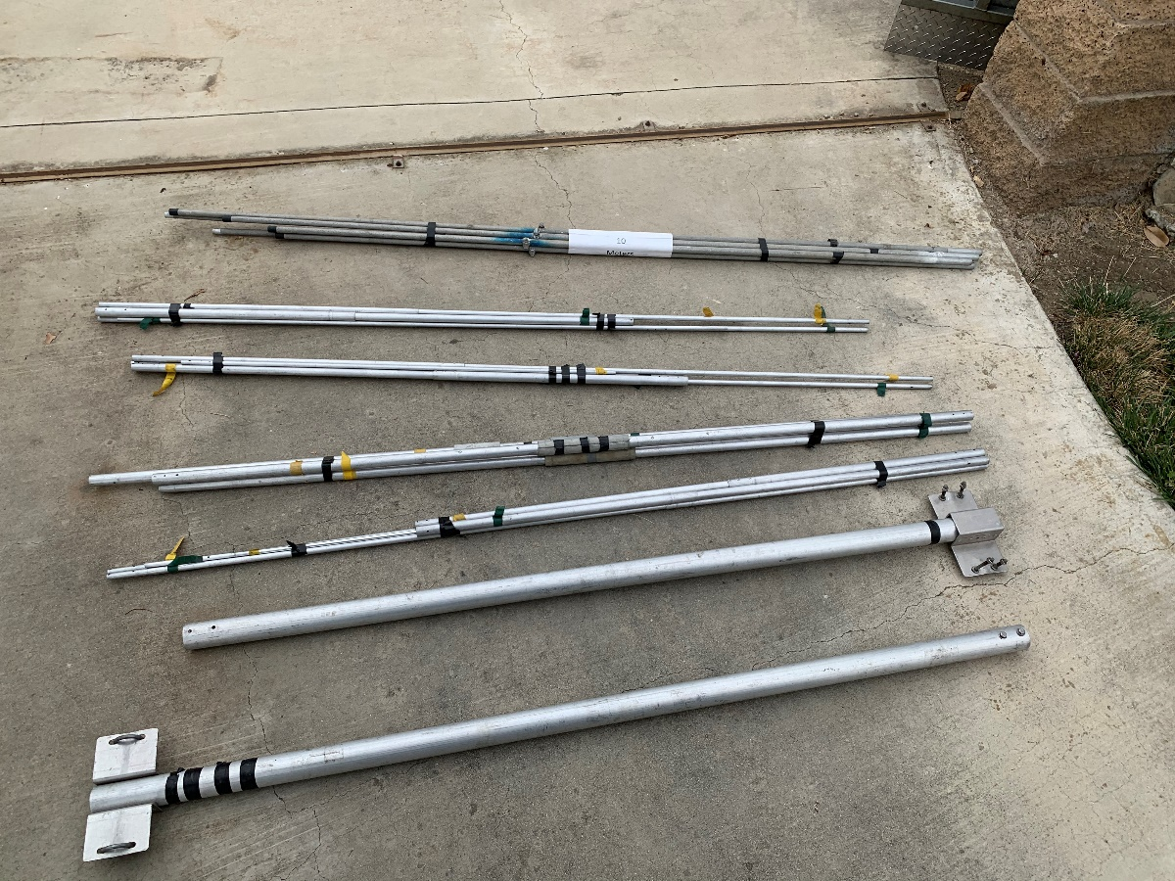
Antenna Pieces #30 & #31 continued:
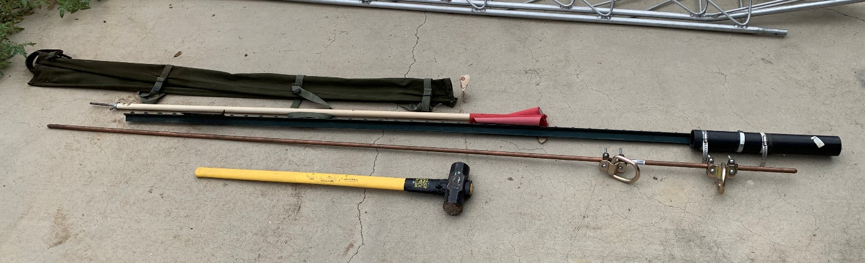
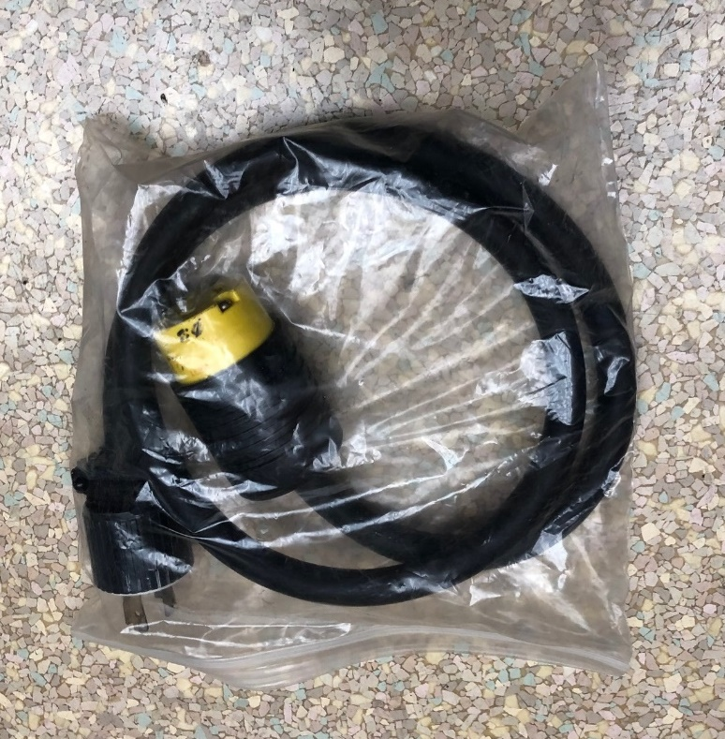
#34
#35
Empty Bag
#38
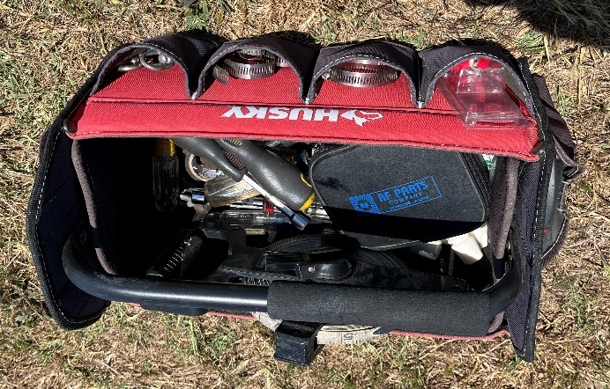
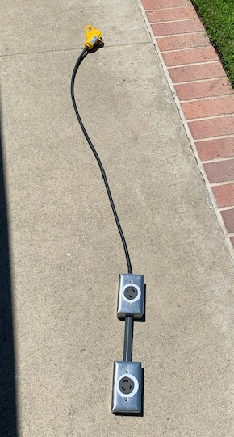
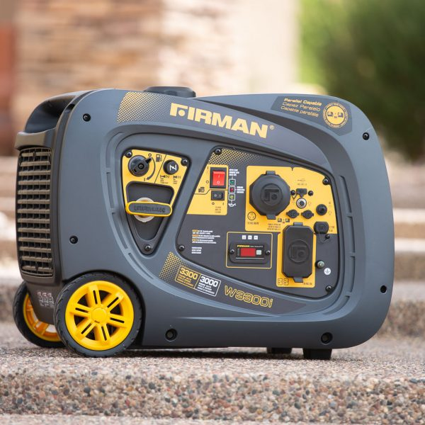
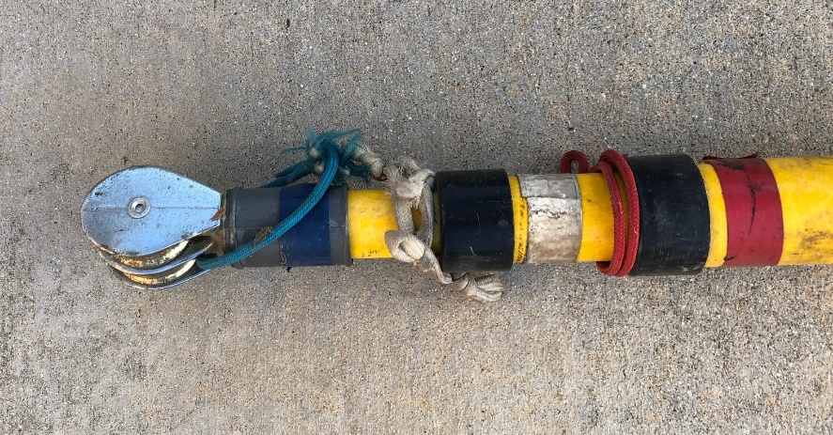
#43
#42
#41
#39
& #40

